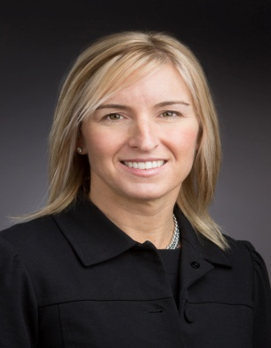 | Kristin Kraeger, Esq.  Managing Director, National Directors & Officers and Fiduciary Product/Practice Leader  Financial Services Group, Aon Risk Solutions
Current Responsibilities: | Kristin is a Managing Director and the National D&O and Fiduciary Product/Practice Leader within the Financial Services Group.  Kristin works directly with the senior legal and underwriting leadership with our insurer partners on manuscript policy language and Aon exclusive contract terms. She is directly involved with the brokering/[policy negotiation of many of our Fortune 500 D&O accounts. She serves as a senior legal resource advocating for our client on complex corporate claims. Kristin also is the national leader on the exclusive endorsement of Aon as the Biotechnology Industry Organization’s (“Bio”) broker offering an executive liability business solution for Bio and it’s state affiliates’’ member base.
Special Areas of Expertise: | Kristin has over twenty years of legal experience, primarily insurance defense and particularly directors’ and officers’ liability. Previously she practiced in the litigation department at one of Boston’s oldest and largest law firms where she worked in the firm’s litigation department on complex Directors’ and Officers’ coverage and liability actions, as well as, cases involving securities and employment law. Her practice included work with both for profit (public and private) and not-for-profit companies across the country. Her D&O liability experience also includes over 10 years of advising clients on IPO placements and risks. She has advocated for clients on hundreds of class action securities litigation and regulatory investigations. Her work has also included providing legal advice to directors’ and officer’ on the subject of corporate governance.  Kristin speaks often at national and global industry events on numerous D&O related topics ranging from Securities Litigation, D&O Marketplace Trends, IPO Preparedness and Contract Certainty.
Prior Industry Experience: | Kristin held a similar position with Boston-based regional insurance broker.
Education: | - College of the Holy Cross  - Suffolk University Law School.  - All American and Academic All American honors in Track & Field. Dean’s List, National Constitutional Law Team and the Moot Court Board.  - She taught Legal Research, Writing and Advocacy at Boston University Law School for 10 years.
Professional Designations/  Affiliations: | - Admitted to practice in the Commonwealth of Massachusetts and the United States District Court for the District of Massachusetts.  - Member of the Boston Bar Association, Massachusetts Bar Association, Women’s Bar Association and the American Bar Association.  - She is also a member of the Professional Liability Underwriters Society (PLUS).

